Oracle Internet Directory (IDM Single Node) - Blueprint Information

# Overview

The purpose of this document is to describe the Oracle Internet Directory blueprint (as part of the IDM Single Node blueprint) in detail. The goal of the blueprint is to allow for provisioning and configuration of a single node Oracle Internet Directory (OID) instance in an automated and repeatable fashion.

The following components and versions are installed as part of the OID instance:

1. Oracle RDBMS 10.2.0 (Database Node)
2. Oracle Application Server Repository Creation Assistant (Oracle AS RepCA) 10.1.4.0.1 (Application Node)
3. OID of Oracle Application Server Infrastructure 10g 10.1.4.3.0 (Application Node)

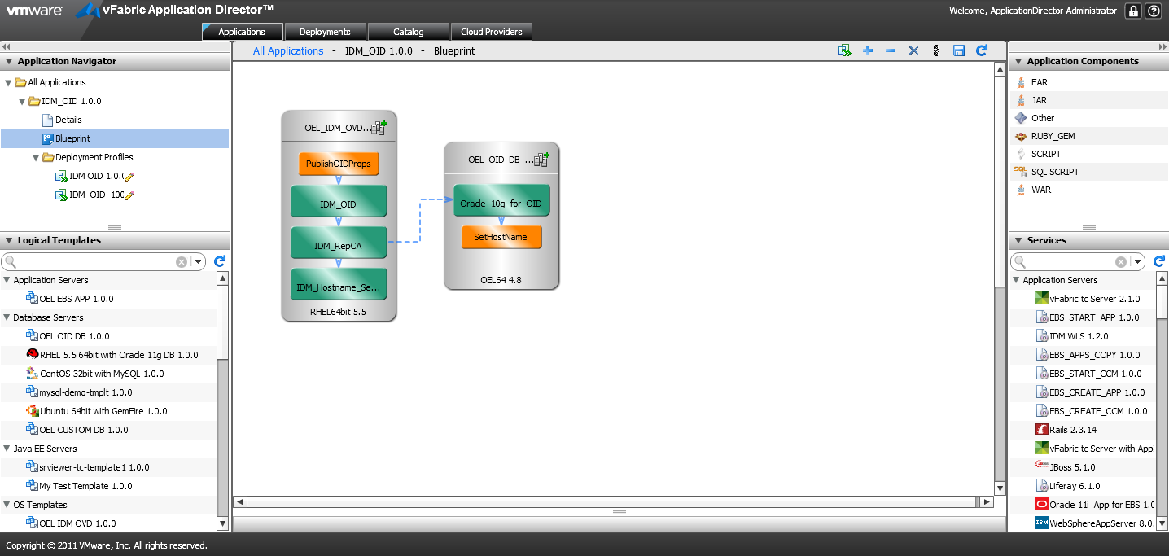

# High level BLUEPRINT Design

Conceptually, the blueprint design consists of the tasks described below. These tasks are listed in chronological order:

1. Setup Host Name (Database Node)
2. Setup Host Name (Application Node)
3. Install Oracle RDBMS 10.2.0 (Database Node)
4. Install Oracle Application Server Repository Creation Assistant 10.1.4.0.1 (Application Node)
5. Install OID of Oracle Application Server Infrastructure 10g 10.1.4.3.0 (Application Node)
6. Publish OID Properties (Application Node)

## Files

You will need access to create the following file repository that contains the necessary installers and configuration files needed. We will refer to this repository as the “Mount Point Location” in this document.

$MOUNTPOINTLOCATION/IDM:

repca/ Installation and configuration directory of Oracle AS RepCA 10.1.4.0.1

Disk1/ Installation package (Disk1) of Oracle AS RepCA

Disk2/ Installation package (Disk2) of Oracle AS RepCA

1014repca/ Installation patch of Oracle AS RepCA

Templates/ Oracle AS RepCA installation and configuration templates

repca.rsp Oracle AS RepCA silent installation response file Template

repca_install_load.rsp Oracle AS RepCA silent initial load response file Template

oraInst.loc Oracle AS RepCA installation location file

rootsh_rsp.txt Response file when running “root.sh”

OID/ Installation and configuration directory of OID

oid_101401/ Installation package of OID 10.1.4.0.1

oid_101430/ Installation package of OID 10.1.4.3.0

1014im/ Installation patch of OID 10.1.4

Templates/ OID installation and configuration templates

add_oam_objects.ldif ldif file to add Oracle Access Management (OAM) objects

change_orcladmin_password.ldif ldif file to change user “orcladmin” password

mod_nonsslport.ldif ldif file to modify OID non-SSL port to 389

mod_sslport.ldif ldif file to modify OID SSL port to 636

mod_vmwperson.ldif ldif file to modify “vmwperson” object class

oid_install.rsp OID silent installtion response file Template

oid_patch_install.rsp OID patch silent installation response file Template

rootsh_rsp.txt Response file when running “root.sh”

perforce/Templates/ Perforce templates used for inter-blueprint communications

oid.properties OID properties file

You will also need below files to configure the scripts and services within this blueprint. Please refer to the following sections for details and their corresponding script/service.

IDM_Hostname_Setup_INSTALL.txt

SetHostName_INSTALL.txt

Oracle_10g_for_OID_INSTALL.txt

Oracle_10g_for_OID_CONFIGURE.txt

IDM_RepCA_INSTALL.txt

IDM_OID_INSTALL.txt

IDM_OID_CONFIGURE.txt

PublishOIDProps_INSTALL.txt

## Setup Host Name (Database Node)

The “Setup Host Name” task sets the hostname for the database machine that’s provisioned. It’s defined as a blueprint script.

Properties:

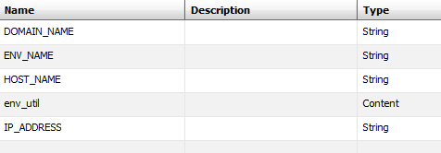

Actions:

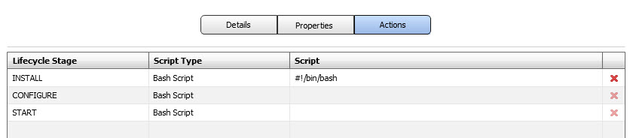

Install Script:

Please refer to file **SetHostName.txt** to copy the script as the INSTALL Bash Script.

## Install Oracle RDBMS 10.2.0 (Database Node)

The “Install Oracle RDBMS 10.2.0” task installs a server instance of Oracle RDBMS 10.2.0. It’s defined as a blueprint service.

Properties:

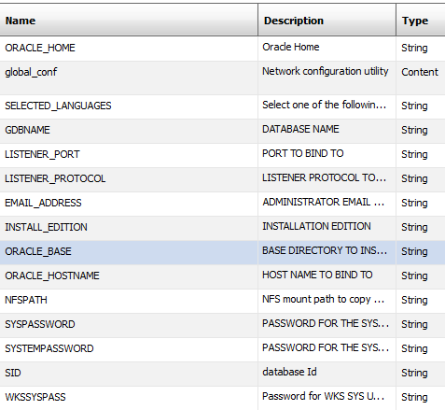

Actions:

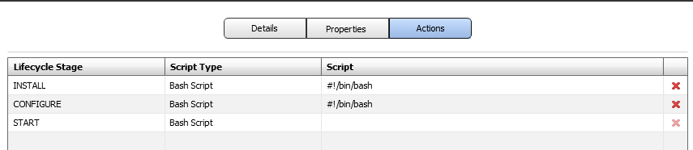

Install Script:

Please refer to file **Oracle_10g_for_OID_INSTALL.txt** to copy the script as the INSTALL Bash Script.

Please refer to file **Oracle_10g_for_OID_CONFIGURE.txt** to copy the script as the CONFIGURE Bash Script.

## Setup Host Name (Application Node)

The “Setup Host Name” task sets the hostname for the OID machine that’s provisioned. It’s defined as a blueprint service.

Properties:

Service Definition

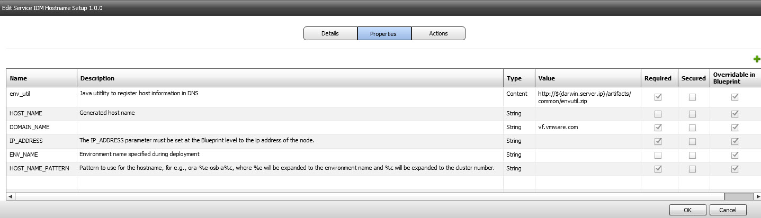

Blueprint Definition

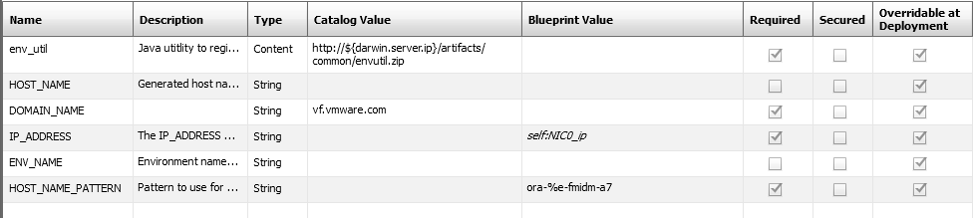

Actions:



Install Script:

Please refer to file **IDM_Hostname_Setup_INSTALL.txt** to copy the script as the INSTALL Bash Script.

## Install Oracle Application Server Repository Creation Assistant 10.1.4.0.1 (Application Node)

The “Install Oracle Application Server Repository Creation Assistant 10.1.4.0.1 (Application Node)” task installs Oracle Application Server Repository Creation Assistant to load data into OID Metadata Repository. It’s defined as a blueprint service.

Properties:

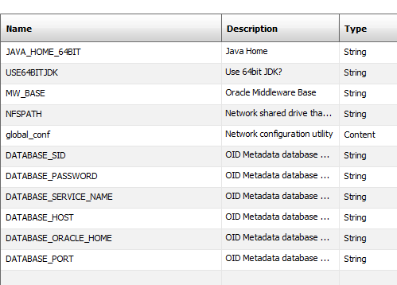

Actions:



Install Script:

Please refer to file **IDM_RepCA_INSTALL.txt** to copy the script as the INSTALL Bash Script.

## Install OID of Oracle Application Server Infrastructure 10g 10.1.4.3.0 (Application Node)

The “Install OID of Oracle Application Server Infrastructure 10g 10.1.4.3.0 (Application Node)” task installs an OID server instance. It’s defined as a blueprint service.

Properties:

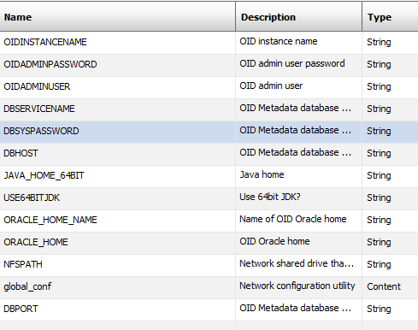

Actions:



Install Script:

Please refer to file **IDM_OID_INSTALL.txt** to copy the script as the INSTALL Bash Script.

Please refer to file **IDM_OID_CONFIGURE.txt** to copy the script as the CONFIGURE Bash Script.

## Publish OID Properties

The “Publish OID Properties” task publishes the OID information to Perforce. It’s defined as a blueprint script.

Properties:

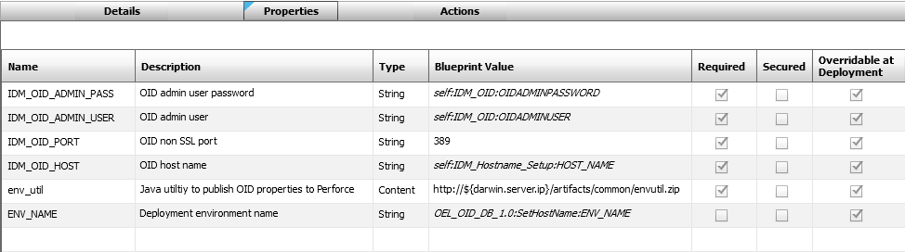

Actions:



Install Script:

Please refer to file **PublishOIDProps_INSTALL.txt** to copy the script as the INSTALL Bash Script.